Vulnerability
- Vulnerability---a weakness of an asset (resource) or a group of assets that can be exploited by one or more threats
  - Vulnerability---password is vulnerable for dictionary or exhaustive key attacks
- Information security vulnerabilities are weaknesses that expose an organization to risk.
- Through employees: Social interaction, Customer interaction, Discussing work in public locations, Taking data out of the office (paper, mobile phones, laptops), Emailing documents and data, Mailing and faxing documents, Installing unauthorized software and apps, Removing or disabling security tools, Letting unauthorized persons into the office (tailgating) , Opening spam emails, Connecting personal devices to company networks, Writing down passwords and sensitive data, Losing security devices such as id cards, Lack of information security awareness, Keying data
- Through former employees---Former employees working for competitors, Former employees retaining company data, Former employees discussing company matters
- Though Technology---Social networking, File sharing, Rapid technological changes, Legacy systems, Storing data on mobile devices such as mobile phones, Internet browsers
Through hardware---. Susceptibility to dust, heat and humidity, Hardware design flaws, Out of date hardware, Misconfiguration of hardware
- Through software---Insufficient testing, Lack of audit trail, Software bugs and design faults, Unchecked user input, Software that fails to consider human factors, Software complexity (bloatware), Software as a service (relinquishing control of data), Software vendors that go out of business or change ownership
- Through Network---Unprotected network communications, Open physical connections, IPs and ports, Insecure network architecture, Unused user ids, Excessive privileges, Unnecessary jobs and scripts executing , Wifi networks
- Through IT Management---Insufficient IT capacity , Missed security patches, Insufficient incident and problem management, Configuration errors and missed security notices , System operation errors, Lack of regular audits, Improper waste disposal, Insufficient change management, Business process flaws, Inadequate business rules, Inadequate business controls, Processes that fail to consider human factors, Overconfidence in security audits, Lack of risk analysis, Rapid business change, Inadequate continuity planning Lax recruiting processes
- Partners and suppliers---Disruption of telecom services, Disruption of utility services such as electric, gas, water, Hardware failure, Software failure, Lost mail and courier packages, Supply disruptions, Sharing confidential data with partners and suppliers
Security Vulnerabilities
Know your vulnerabilities
  - OWASP Open Web application Security project
(http://www.owasp.org)
  - National Vulnerability Database
(http://nvd.nist.gov)
  - SANS Top 20
(www.sans.org/top20)
  - Others
  - What is Cross Site Scripting?

What is cross-site scripting?
Cross-site scripting (XSS) is an exploit where the attacker attaches code onto a legitimate website that will execute when the victim loads the website. That malicious code can be inserted in several ways. Most popularly, it is either added to the end of a url or posted directly onto a page that displays user-generated content. In more technical terms, cross-site scripting is a client-side code injection attack.
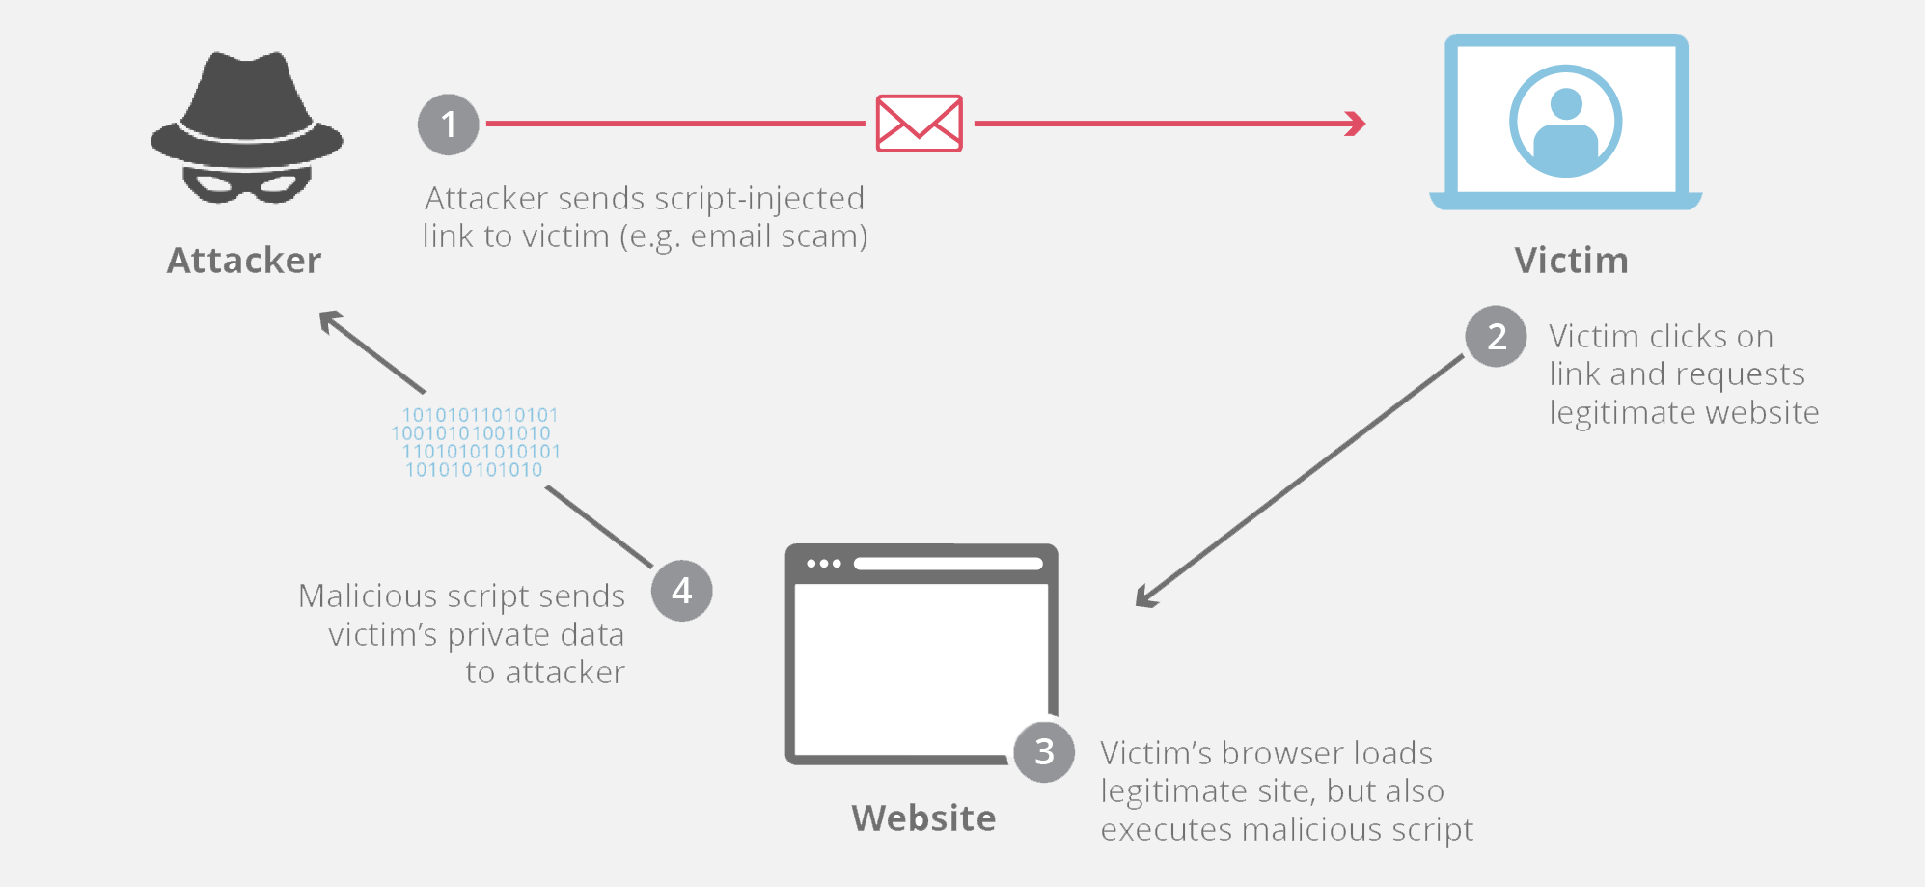

What is client-side code?
Client-side code is JavaScript code that runs on a user’s machine. In terms of websites, client-side code is typically code that is executed by the web browser after the browser loads a web page. This is in contrast to server-side code, which is executed on the host’s web server. Client-side code is very useful with interactive webpages; interactive content runs faster and more reliably since the user’s computer doesn’t have to communicate with the web server every time there is an interaction. Browser-based games are one popular platform for client-side code, since the client-side code can ensure the game runs smoothly regardless of connectivity issues.
Code that runs client side is very popular in modern web development and is utilized on most modern websites. Since cross-site code is a staple of the modern web, cross-site scripting has become one of the most frequently reported cyber-security vulnerabilities, and cross-site scripting attacks have hit major sites such as YouTube, Facebook, and Twitter.

What is an example of cross-site scripting?
One useful example of cross-site scripting attacks is commonly seen on websites that have unvalidated comment forums. In this case, an attacker will post a comment consisting of executable code wrapped in ‘<script></script>’ tags. These tags tell a web browser to interpret everything between the tags as JavaScript code. Once that comment is on the page, when any other user loads that website, the malicious code between the script tags will be executed by their web browser, and they will become a victim of the attack.

How can an attacker use cross-site scripting to cause harm?
JavaScript cross-site scripting attacks are popular because JavaScript has access to some sensitive data that can be used for identity theft and other malicious purposes. For example, JavaScript has access to cookies*, and an attacker could use an XSS attack to steal a user’s cookies and impersonate them online. JavaScript can also create HTTP requests, which can be used to send data (such as stolen cookies) back to the attacker. Additionally, client-side JavaScript can also help an attacker gain access to APIs that contain geolocation coordinates, webcam data, and other sensitive information.
A typical cross-site scripting attack flow is as follows:
- The victim loads a webpage and the malicious code copies the user’s cookies
- The code then sends an HTTP request to an attacker’s webserver with the stolen cookies in the body of the request.
- The attacker can then use those cookies to impersonate the user on that website for the purpose of a social engineering attack or even to access bank account numbers or other sensitive data.
*Cookies are temporary login credentials saved on a user’s computer. For example when a user logs onto a site like Facebook, the site gives them a cookie so that if they close the browser window and go back to Facebook later that day, they are automatically authenticated by the cookie and won’t need to login again.

What are the different types of cross-site scripting?
The two most popular types of cross-site scripting attacks are reflected cross-site scripting and persistent cross-site scripting.

Reflected cross-site scripting
This is the most commonly seen cross-site scripting attack. With a reflected attack, malicious code is added onto the end of the url of a website; often this will be a legitimate, trusted website. When the victim loads this link in their web browser, the browser will execute the code injected into the url. The attacker usually uses some form of social engineering to trick the victim into clicking on the link.
For example, a user might receive a legitimate-looking email that claims to come from their bank. The email will ask them to take some action on the bank’s website, and provide a link. The link may end up looking something like this:
http://legitamite-bank.com/index.php?user=&script>here is some bad code!</script>
Although the first part of the url looks safe and contains the domain of a trusted website, the code injected onto the end of the url can be malicious.

Persistent cross-site scripting
This happens on sites that let users post content that other users will see, such as a comments forum or social media site, for example. If the site doesn’t properly validate the inputs for user-generated content, an attacker can insert code that other users’ browsers will execute when the page loads. For example an attacker might go to an online dating site might put something like this in their profile:
"Hi! My name is Dave, I enjoy long walks on the beach and <script>malicious code here</script>"
Any user that tries to access Dave’s profile will become a victim to Dave’s persistent cross-site scripting attack.

How to prevent cross-site scripting
There is no single strategy for mitigating cross-site scripting, and different types of web applications require different levels of protection. A number of protective measures can be taken, below we will outline a few.
If possible, avoiding HTML in inputs - One very effective way to avoid persistent cross-site scripting attacks is to prevent users from posting HTML into form inputs. There are other options which let users create rich content without the use of HTML, such as markdown and WYSIWYG editors.
Validating inputs - Validation means implementing rules that prevent a user from posting data into a form that doesn’t meet certain criteria. For example, an input that asks for the user’s “Last Name” should have validation rules that only let the user submit data consisting of alphanumeric characters. Validation rules can also be set to reject any tags or characters commonly used in cross-site scripting, such as “<script>” tags.
Sanitizing data - Sanitizing data is similar to validation, but it happens after the data has already been posted to the web server, yet still before it is displayed to another user. There are several online tools that can sanitize HTML and filter out any malicious code injections.
Taking cookie security measures - Web applications can also set special rules for their cookie handling that can mitigate cookie-theft via cross-site scripting attacks. Cookies can be tied to particular IP addresses so that cross-site scripting attackers cannot access them. Additionally, rules can be created to block JavaScript from accessing cookies altogether.
Setting WAF rules - A WAF can also be configured to enforce rules which will prevent reflected cross-site scripting. These WAF rules employ strategies that will block strange requests to the server, including cross-site scripting attacks. The Cloudflare WAF offers turnkey installation and protects web applications from cross-site scripting, DDoS attacks, SQL injection, and other common threats.

    - In it’s simplest form, it’s a process that can occur anywhere a web application uses input from a malicious user to generate output without validating or encoding the input.

    - During a Cross Site Scripting attack, a malicious source sends a script that is executed by the end user’s browser. It allows attackers to embed code from one webpage into another webpage by changing its HTML code.
It’s been used to deface web sites, conduct phishing attacks, or it can take over a user’s browser and force them to execute commands they’re unaware of.
    - Cross Site Scripting attacks usually come in the form of JavaScript however, any active content poses a potential danger.
  - Prevention
    - Validate the users input against what is expected
    - Encode user supplied output
    - After you believe you’ve done the right things during code development, inspect your code with a scan.
  - What is SQL Injection
    - SQL injection is the actual injection of SQL commands into web applications through user input fields.

    - When an application uses internal SQL commands and you also have user input capabilities (like a login screen), SQL commands can be injected that can create, read, update, or delete any data available to the application.
  - Prevention
    - You can put tight constraints on user inputs. But the best method of preventing SQL injection is to avoid the use of dynamically generated SQL in your code. Instead use stored or canned procedures.
And then again, run a scan to make sure your application is not vulnerable to SQL injections

What is SQL injection (SQi)?
Structured Query Language (SQL*) Injection is a code injection technique used to modify or retrieve data from SQL databases. By inserting specialized SQL statements into an entry field, an attacker is able to execute commands that allow for the retrieval of data from the database, the destruction of sensitive data, or other manipulative behaviors.
With the proper SQL command execution, the unauthorized user is able to spoof the identity of a more privileged user, make themselves or others database administrators, tamper with existing data, modify transactions and balances, and retrieve and/or destroy all server data.
In modern computing, SQL injection typically occurs over the Internet by sending malicious SQL queries to an API endpoint provided by a website or service (more on this later). In its most severe form, SQL injection can allow an attacker to gain root access to a machine, giving them complete control.
*SQL is a programming language used to maintain most databases.

How does a SQL injection attack work?
Imagine a courtroom in which a man named Bob is on trial, and is about to appear before a judge. When filling out paperwork before the trial, Bob writes his name as “Bob is free to go”. When the judge reaches his case and reads aloud “Now calling Bob is free to go”, the bailiff lets Bob go because the judge said so.
While there are slightly different varieties of SQLi, the core vulnerability is essentially the same: a SQL query field that is supposed to be reserved for a particular type of data, such as a number is instead passed unexpected information, such as a command. The command, when run, escapes beyond the intended confines, allowing for potentially nefarious behavior. A query field is commonly populated from data entered into a form on a webpage.
Let’s look at at a simple comparison between normal and malicious SQL statements:

Normal SQL query:
In this normal SQL query, the studentId string is passed into a SQL statement. The goal is to look through the list of students for a student that matches the studentId entered. Once found, that student’s record will be returned. Put simply, the command says “go find this user and give me their data”.
The code might look something like this:
studentId = getRequestString("studentId");
lookupStudent = "SELECT * FROM students WHERE studentId = " + studentId

If a student enters a student ID of 117 inside a webpage form labelled 'Please enter your student ID number'
the resulting SQL query will look like:
SELECT * FROM students WHERE studentId = 117;
This command will return the record for the particular student with a studentId, which is what the developer who wrote the API expects to have happen.

SQL Injection query:
In this example, an attacker instead enters a SQL command or conditional logic into the input field, he enters a student ID number of:
Where normally the query would search the database table for the matching ID, it now looks for an ID or tests to see if 1 is equal to 1. As you might expect, the statement is always true for every student in the column, and as a result, the database will return all data from the students table back to the attacker making the query.
SELECT * FROM students WHERE studentId = 117 OR 1=1;
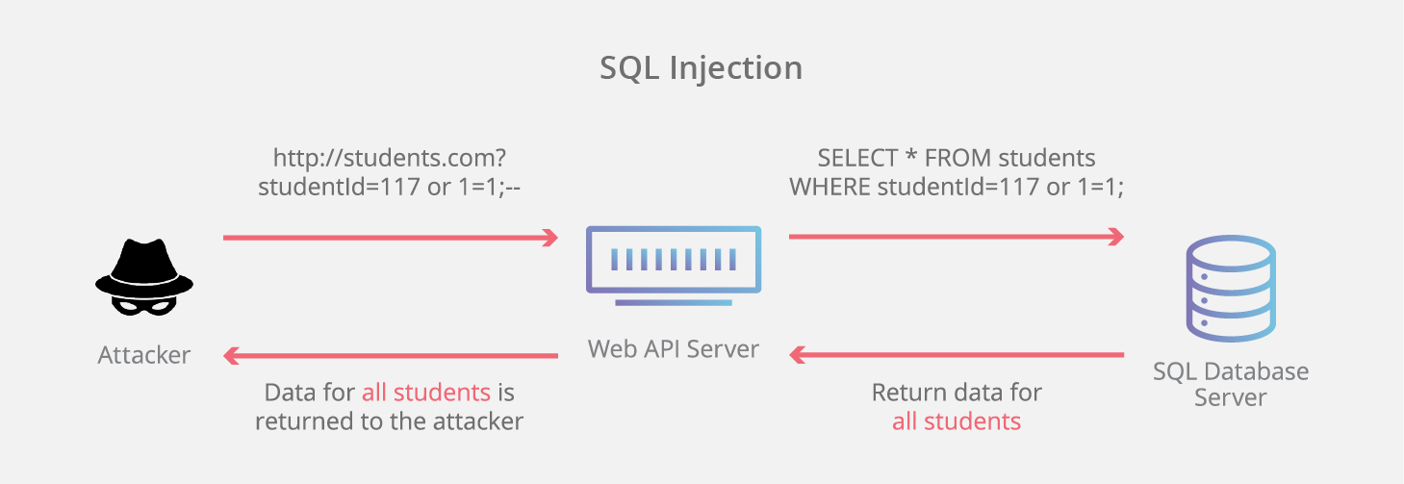
SQLi works by targeting a vulnerable Application Programming Interface or API. An API in this case is the software interface through which a server receives and responds to requests.
Commonly used tools exist that allow a malicious actor to automatically search through a website looking for forms, and then attempt to input various SQL queries that may generate a response that the website’s software developers did not intend in order to exploit the database.
SQL injections are easy to implement, and interestingly, also fairly easy to prevent given the proper development practices. The reality is more murky, as tight deadlines, inexperienced developers, and legacy code often result in variable code quality and security practices. A single vulnerable field on any form or API endpoint across a website that has access to a database may be sufficient to expose a vulnerability.

How is a SQL Injection attack prevented?
There are number of methods for reducing the risk of a data breach due to SQL injection. As a best practice, several strategies should be utilized. Let’s explore a few of the more common implementations:
- Use of Prepared Statements (with Parameterized Queries) - This method of sanitizing database inputs involves forcing the developers to first define all the SQL code, and then to pass only specific parameters to the SQL query; data entered is explicitly given a limited scope that it can not expand beyond. This allows the database to make the distinction between data that’s being input and code that’s to be run, regardless of the type of data supplied in the input field. Some object-relational mapping (ORM) libraries are commonly utilized for this purpose, as some versions will sanitize database inputs automatically.
- Escape All User Supplied Input - When writing SQL, specific characters or words have particular meaning. For example, the ‘*’ character means “any” and the words “OR” is a conditional. To circumvent users who enter these characters either accidentally or maliciously into an API request to the database, user supplied input can be escaped. Escaping a character is the way of telling the database not to parse it as a command or conditional but instead treat it as literal input.
- Use of Stored Procedures - Although not a robust security strategy by itself, stored procedures can help limit the risk associated with SQL injection. By properly limiting the permissions of the database account running SQL queries, even non-robust application code that is vulnerable to SQL injection will lack the permissions necessary to manipulate unrelated database tables. Stored procedures may also check the type of input parameters, preventing data to be input that violates the type the field is designed to receive. In instances where static queries are insufficient, stored procedures are typically to be avoided.
- Enforce Least Privilege - As a general rule, in all instances where a website needs to use dynamic SQL, it is important to reduce the exposure to SQL injection by limiting permissions to the narrowest scope required to execute the relevant query. In its most obvious form, this means that an administrative account should in no instance be executing SQL commands as a result of a API call from an unauthorized request. While stored procedures are best utilized for static queries, enforcing least privilege can help reduce the risks of dynamic SQL queries.

What is a compound SQL injection attack?
In order to circumvent security measures, clever attackers will sometimes implement multi-vector attacks against a targeted website. While a single attack may be mitigated, it can also become the focus of attention for database administrators and information security teams. DDoS attacks, DNS hijacking and other methods of disruption are sometimes used as a distraction to implement sweeping SQL injection attacks. As a result, a comprehensive threat mitigation strategy provides the widest range of protection. Cloudflare’s web application firewall, DDoS mitigation and DNS securitycomprise core elements of a holistic security strategy.

SANS Top 20 Security Vulnerabilities